Microsoft logo

Robotic Process Automation in a Day

Lab 7 – Use Microsoft Teams to integrate approvals

30 mins

April 2023

Applies to Power Automate Desktop v. 2.31.105.23101 ([more](https://learn.microsoft.com/en-us/power-platform/released-versions/power-automate-desktop))



This document is provided “as-is.” Information and views expressed in this document, including URL and other Internet Web site references, may change without notice. You bear the risk of  
using it. Some examples are fictitious and are for illustration only. No real association is intended  
or inferred. This document does not provide you with any legal rights to any intellectual property in any Microsoft product. You may copy and use this document for your internal reference purposes.

© 2021 Microsoft Corporation. All rights reserved.

## Lab Overview

You will complete the following tasks in this lab, which will complete the end-to-end invoice processing solution:

* Integrate a Microsoft Teams-based approval model and the associated conditional logic into the invoice processing Cloud flow
* Integrate the Desktop flow for entering the invoice information into the approval process
* Integrate Outlook-based approval/rejection notifications into the invoice process
* Perform a test of the end-to-end invoice processing Cloud flow

## Prerequisites

This lab builds on the initial setup lab (lab 1), and labs 2-6 – ensure these labs are complete.

# Use Microsoft Teams to get approval. End to end integration

1. Open the test profile in a browser and navigate to <https://make.powerautomate.com/>
2. Select Solutions from the navigation bar, then open Invoice processing solution.

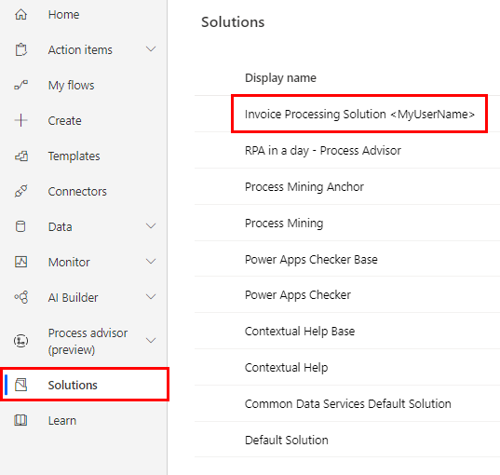

1. Open Use Outlook email to trigger Desktop flow that you created in Lab 5.

1. Click **Edit** link and in the **Details** pane change flow’s name to **Enter invoice information flow** and hit **Save** button.

1. Click Edit.

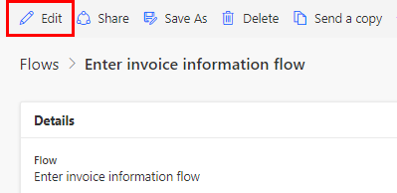

1. Expand Apply to each box. Delete the Send an email (V2) action you have created.

1. Click Add an action.

1. Search teams in the search bar, select Microsoft Teams.

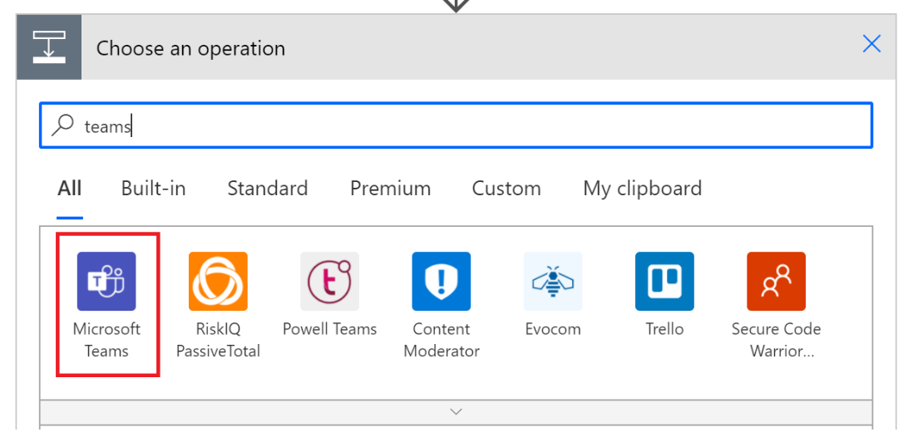

**Note:** For this example, we will use technology called **Adaptive Cards**. Its aim is to let users to design layout for their content that will be displayed in apps (for example Microsoft Teams, Cortana, Outlook) using these apps’ User Experience. For more information please visit: <https://aka.ms/adaptivecards>.

For the purposes of this lab, you can use JSON code that you can find under **lab data packages** in student’s materials. If you are interested in designing your own Adaptive Card, please visit the designer experience at: <https://adaptivecards.io/designer/>.

1. Select Post an Adaptive Card and wait for a response.

1. Use following values:

* Post as: Flow bot
* Post in: Chat with Flow bot
* Message: Input the JSON code from the file: **AdaptiveCard-lab7.json** found in the student lab data packages.
* After you copy-paste the JSON code, replace the following data in the message content:
  1. #BILL TO# with Bill to value *(from dynamic content for action* **Extract information from documents***)*
  2. #CONTACT# with Contact value *(from dynamic content for action* **Extract information from documents***)*
  3. #DATE# with Date value *(from dynamic content for action* **Extract information from documents***)*
  4. #TOTAL# with Total value *(from dynamic content for action* **Extract information from documents***)*

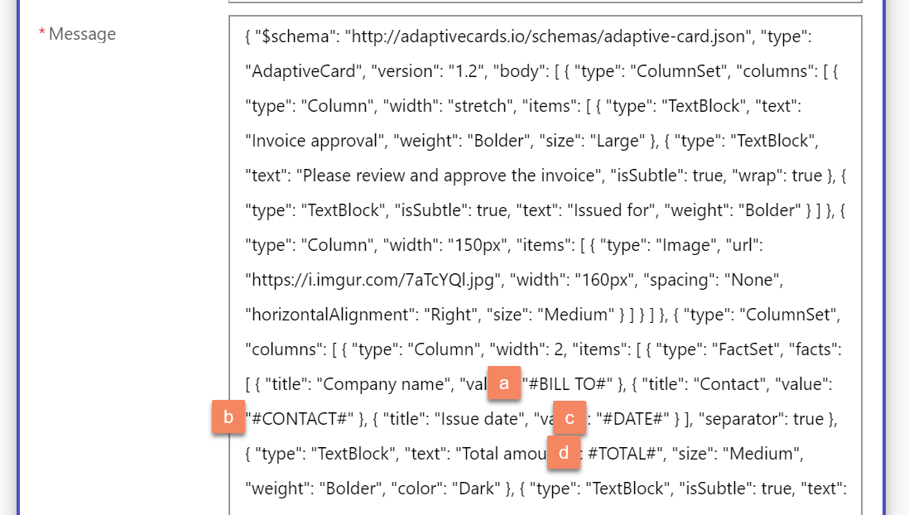

* Update message: Thank you for your response!
* Recipient: Your email address (User ID)

1. Click Add an action.

1. Search for **condition** in the search bar and select Condition in Actions.

1. Click on **Add dynamic content** and select **submitActionId** from **Post adaptive card and wait for a response** outcomes:

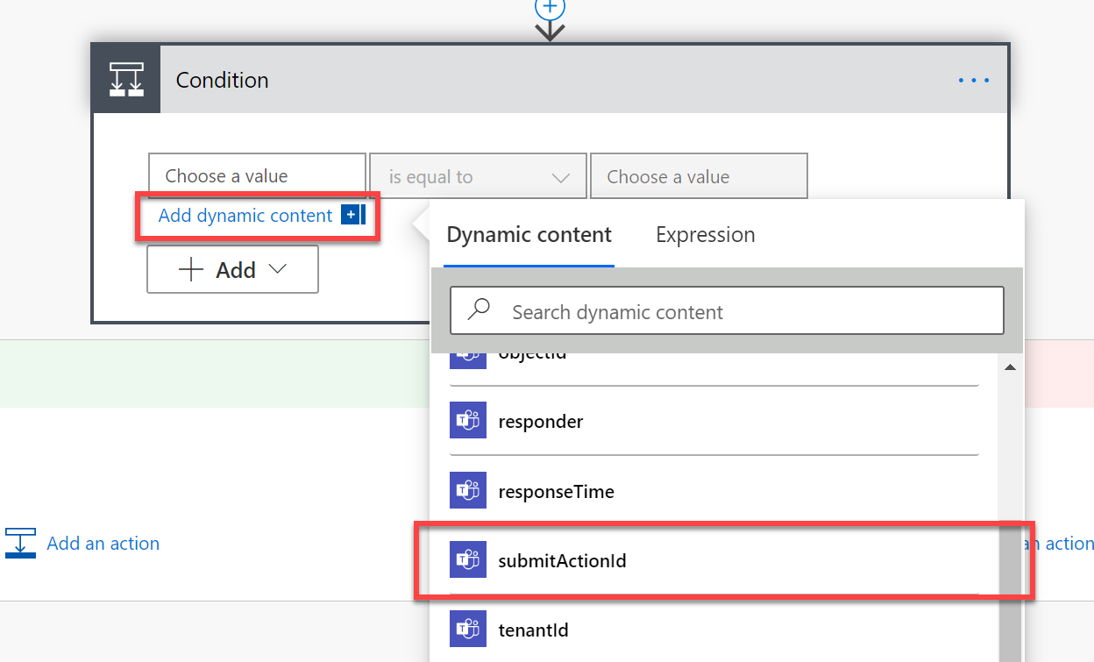

**Tip 1:** If no outcomes for the Teams action can be found, then click on “Add dynamic content” link (1) and then “Expression” (2). **Insert:**   
body('Post_adaptive_card_and_wait_for_a_response')?['submitActionId']  
in the field (3) and click “OK” (4).

**Tip 2:** If you are prompted that the expression is invalid, simply close the prompt and hit “OK” (4) again.

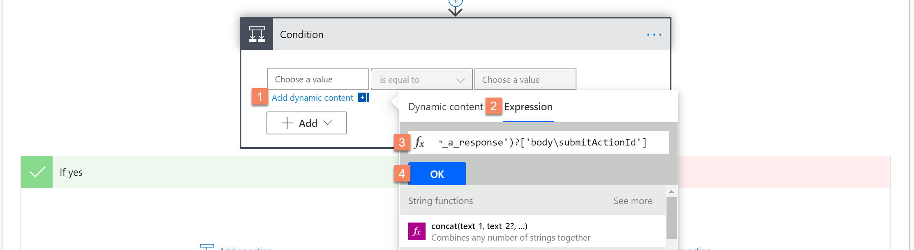

1. Enter ac_approve in choose a value field.

**Note:** Case sensitive. Make sure the capitalization is same as above.

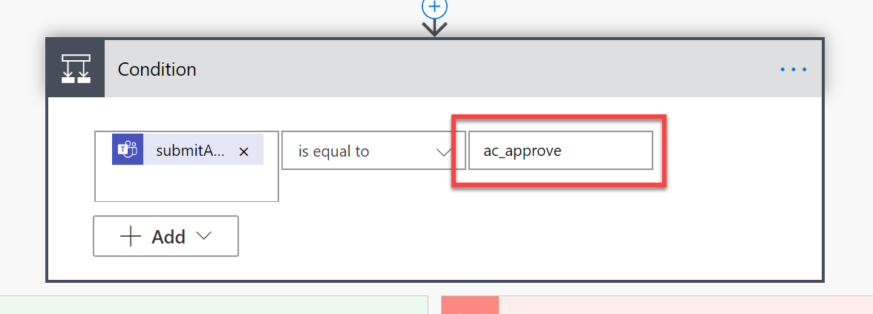

**Note:** The **ac_approve** value was defined in our Adaptive Card JSON payload and represents our **Approve** button that is rendered at runtime.

1. Click Add an action under If Yes branch.

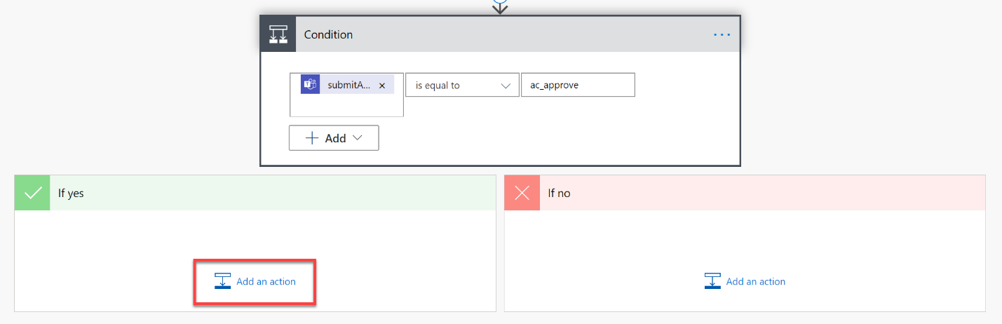

1. If the approval result is Yes, we will launch the desktop flow to process this invoice and then send a confirmation email to the invoice sender.
2. First the Total value needs to be converted to a number. To do that, type “Compose” in the search bar and select the **Compose** action.

1. Select **Add dynamic content**, switch to **Expression** and then select the option “Format data by examples”.

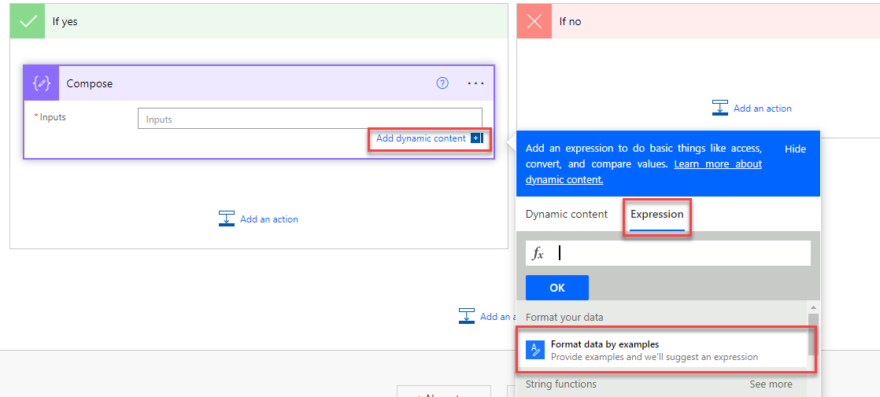

1. Now select the field “Total value” from the list of visible dynamic contents, and then type the following values:

|  |  |
| --- | --- |
| **Example value for Total value** | **Desired output** |
| $3,454.12 | 3454.12 |
| $3,454.12 USD | 3454.12 |

1. Now click “Get expression” button:

1. And click “Apply”

In general, what you received, is an expression, that first replaces dollar sign ($) and/ or USD abbreviation with an empty string and then converts the remaining string to a float number. Assuming the total value is $3,454.12, you will receive: 3454.12.

1. Click **Add an action** below.

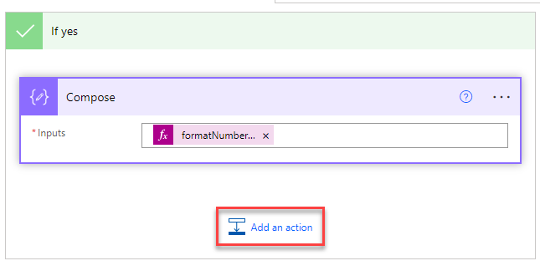

1. Select Run a flow built with Power Automate Desktop.

1. Select Enter an invoice flow.

1. Use these values:

Run Mode: Attended – Runs when you are logged into device

Amount: Outputs (from dynamic content under **Compose** action)

Contact: Contact value (from dynamic content under **Extract information from documents** action)

Account name: Bill to value (from dynamic content under **Extract information from documents** action)

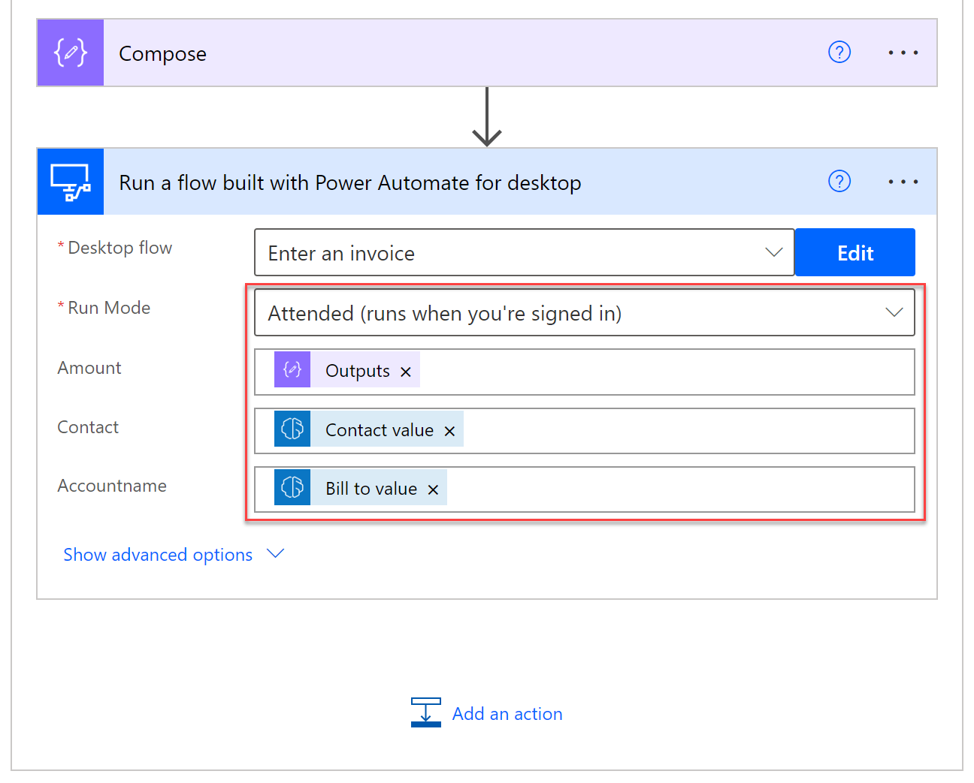

1. Click Add an action inside the **If yes** branch.

1. Select Reply to email (V3) action.

1. Message id: Message Id (from dynamic content for action **When a new email arrives (V3)**)

* Body: Your invoice of amount Total value (from dynamic content under **Extract information from documents** action) is approved.

1. Click Show advanced options.

1. Enter Your invoice is approved in Subject field.

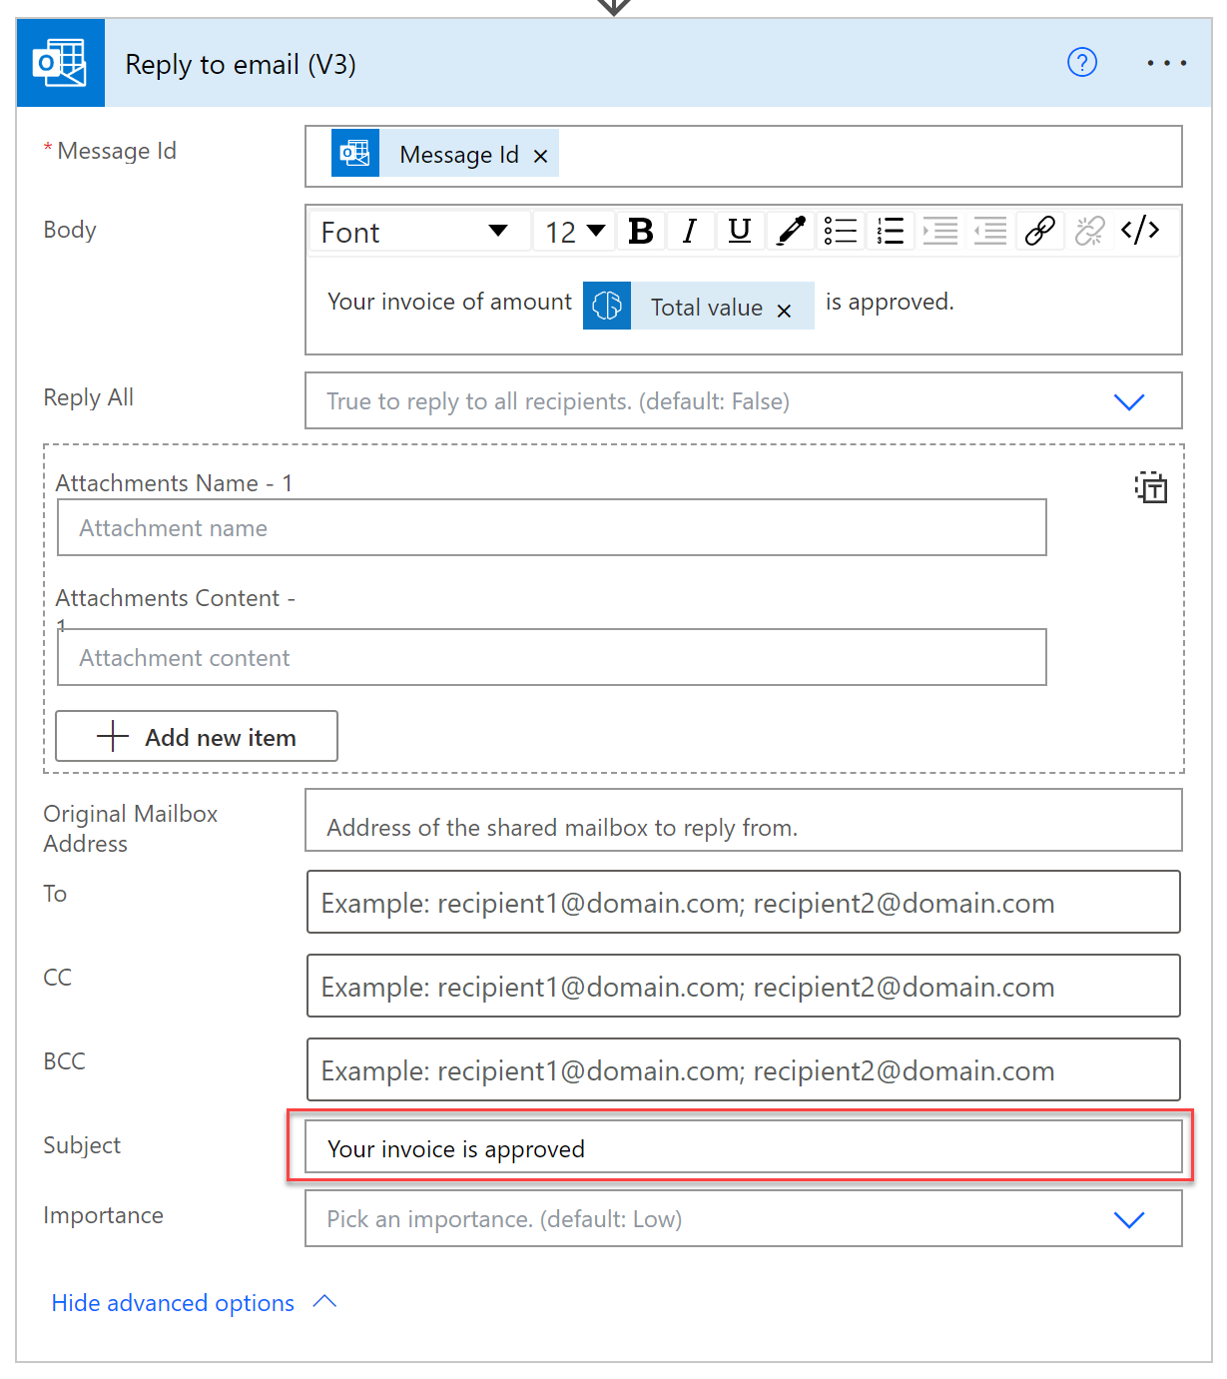

1. Now we will create the steps for the case if the approval result was No.
2. Click Add an action under If no branch.

Select Reply to email action.

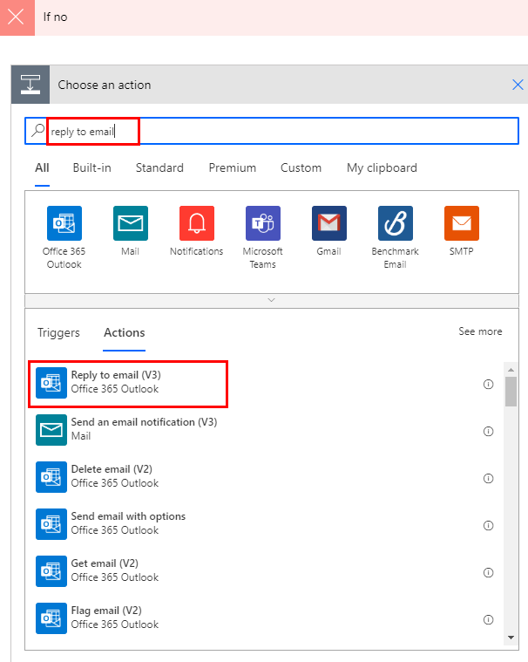

1. Enter the values as the screenshot below:

* Message id: Use Message Id (from dynamic content for action **When a new email arrives (V3)**)
* Body: Your invoice of amount Total value (from dynamic content from AI Builder action) is rejected.
* Click Show advanced options.
* Enter Your invoice is rejected in Subject column.

1. Click Save.

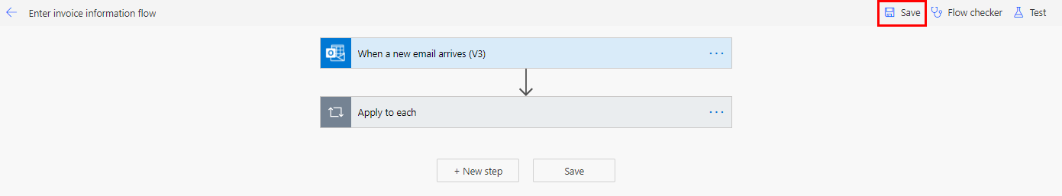

1. Click Test.

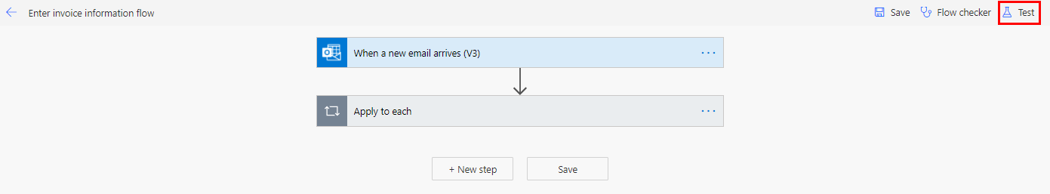

1. Select Manually, then click Test.

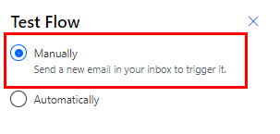

1. In a separate tab, open the Teams app (Note: use the browser version, not the desktop app version) and sign in using the same test account. The web version of Microsoft Teams is available at: <https://teams.microsoft.com/>
2. In another separate tab, open the Office 365 Outlook app. The web version of Microsoft Outlook is available at: <https://outlook.office.com/mail/>
3. Compose a new email with the following settings:
   1. To: *{email address of the user identity you are using in this lab}*
   2. Subject: **New invoice**
   3. Attachments: **newinvoice.jpg** *(from the lab resource files)*
4. Send the email and wait for the flow to run.
5. Wait for an approval request Adaptive Card to you in the Teams tab – Select “Yes” or “No” and then select “Submit” to approve or reject the invoice as desired.
6. In the Outlook tab, check for a confirmation email that matches the option you selected.
7. Repeat the test with the other test case (accept or reject).
8. Like previous labs, you can monitor the run status from the flow details page and run details page.

Check your knowledge

Lab 7

10 mins

1. When we want to send an approval to a user inside of Microsoft Teams, which is the appropriate action, from the Microsoft Teams connector, for us to choose?
2. Post a choice of options as the Flow bot to a user
3. Post an adaptive card wait for a response
4. None of the above
5. Either A or B

Answer: D. Post a choice of options as the Flow bot to a user or Post an adaptive card and wait for a response.

1. When we are entering ‘ac_approve’ in “choose a value field” in the Condition action, we need to make sure the capitalization is same as the options in the Adaptive Card action?
2. True
3. False

Answer: A True – If the capitalization is different, the condition will not be met.

1. After clicking Add an action under If No branch, we need to communicate to our email recipient that their invoice has not been approved. What action do we need to select _______?
2. Reply to email
3. Send an email notification
4. Run a flow built with Power Automate Desktop
5. Run a flow built with Selenium IDE

Answer: A. Reply to email. This will allow our email to look like a reply to the original email, giving it a personal touch.

Information in this document, including URL and other Internet Web site references,  
is subject to change without notice. Unless otherwise noted, the example companies, organizations, products, domain names, e-mail addresses, logos, people, places, and events depicted herein are fictitious, and no association with any real company, organization, product, domain name, e-mail address, logo, person, place or event is intended or should be inferred. Complying with all applicable copyright laws is the responsibility of the user. Without limiting the rights under copyright, no part of this document may be reproduced, stored in or introduced into a retrieval system, or transmitted in any form or by any means (electronic, mechanical, photocopying, recording, or otherwise), or for any purpose, without the express written permission of Microsoft Corporation.

Microsoft may have patents, patent applications, trademarks, copyrights, or other intellectual property rights covering subject matter in this document. Except as expressly provided in any written license agreement from Microsoft, the furnishing of this document does not give you any license to these patents, trademarks, copyrights, or other intellectual property.

The names of manufacturers, products, or URLs are provided for informational purposes only and Microsoft makes no representations or warranties, either expressed, implied, or statutory, regarding these manufacturers or the use of the products with any Microsoft technologies.  
The inclusion of a manufacturer or product does not imply endorsement of Microsoft of the manufacturer or product. Links may be provided to third party sites. Such sites are not under the control of Microsoft and Microsoft is not responsible for the contents of any linked site or any link contained in a linked site, or any changes or updates to such sites. Microsoft is not responsible for webcasting or any other form of transmission received from any linked site. Microsoft is providing these links to you only as a convenience, and the inclusion of any link does not imply endorsement of Microsoft of the site or the products contained therein.

© 2021 Microsoft Corporation. All rights reserved.

Microsoft and the trademarks listed at https://www.microsoft.com/enus/legal/intellectualproperty/Trademarks/Usage/General.aspx  
are trademarks of the Microsoft group of companies. All other trademarks are property of their respective owners.